Name : Bhaumik.M.Patel

Student id : 9012179

Subject : High Quality Software programming

1.Hello word.

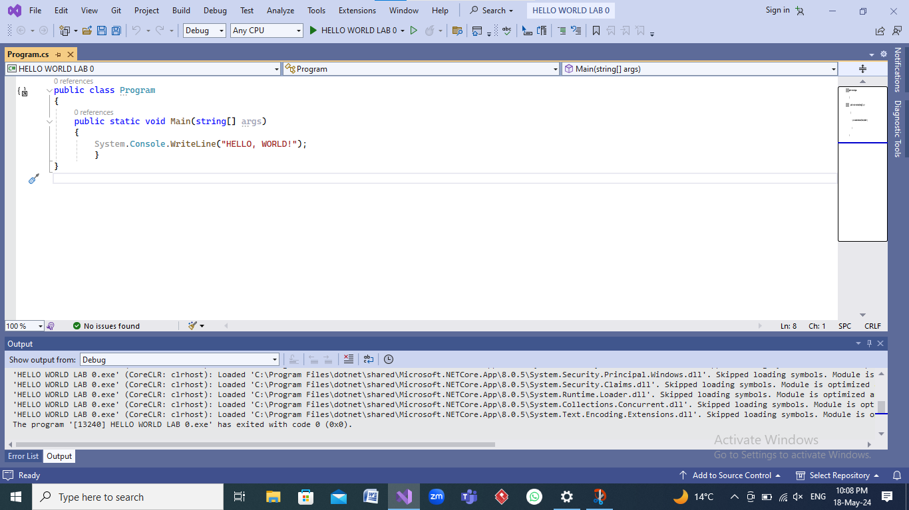

2.Run

